

# Team 24 – Sprint 1 Testing Document

Sakshi Choudhary, Giorgi Khmaladze, Nick Litman, Mihir Somani, Conley Utz

# User Story #4

**Test 1: Given that the user is logged in and has navigated to the account settings page, the user should be able to delete their account.**

Purpose: To meet the acceptance criteria a user has to be able to delete their account which is removed from the database as a consequence.

Steps:

1. The user clicks “DELETE ACCOUNT” 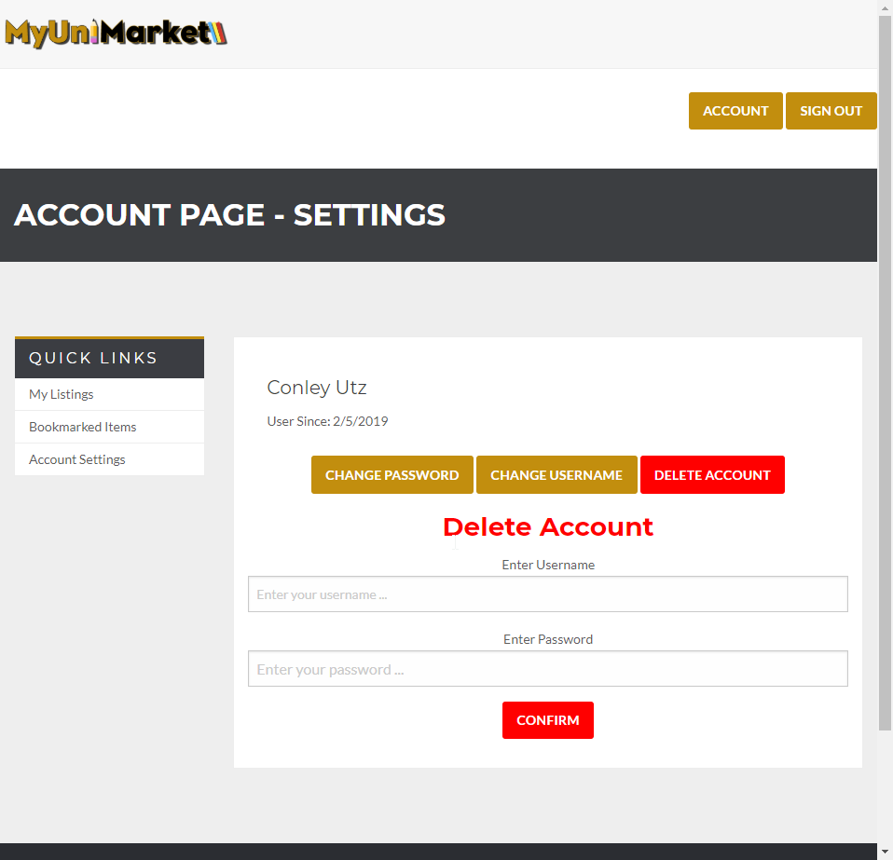
2. The user enters all fields correctly. 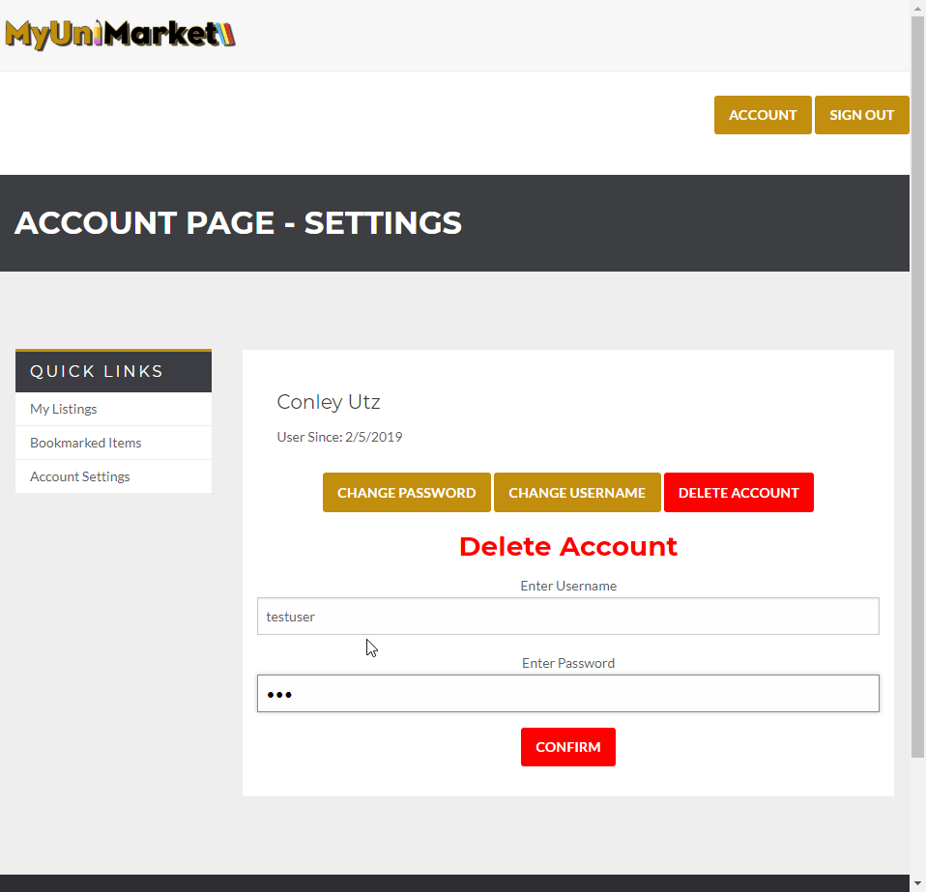
3. The user currently is in the database. 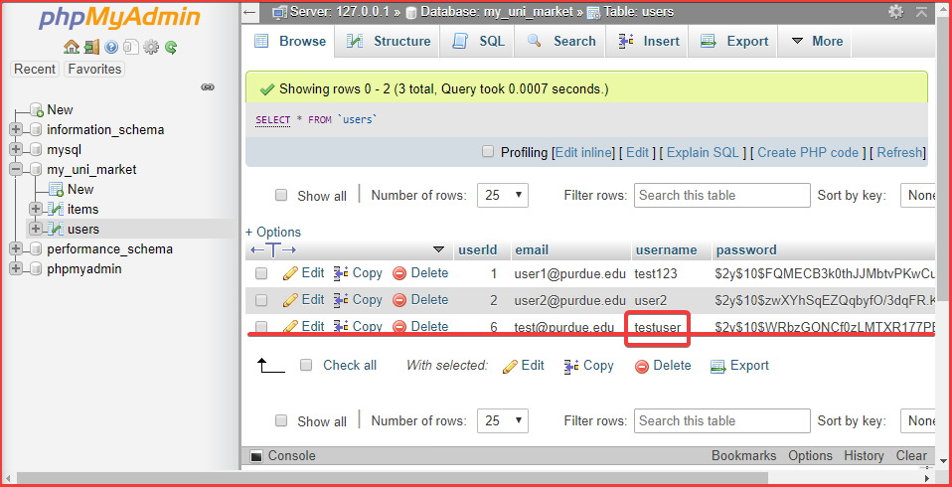
4. The user clicks “CONFIRM” and is logged out automatically. 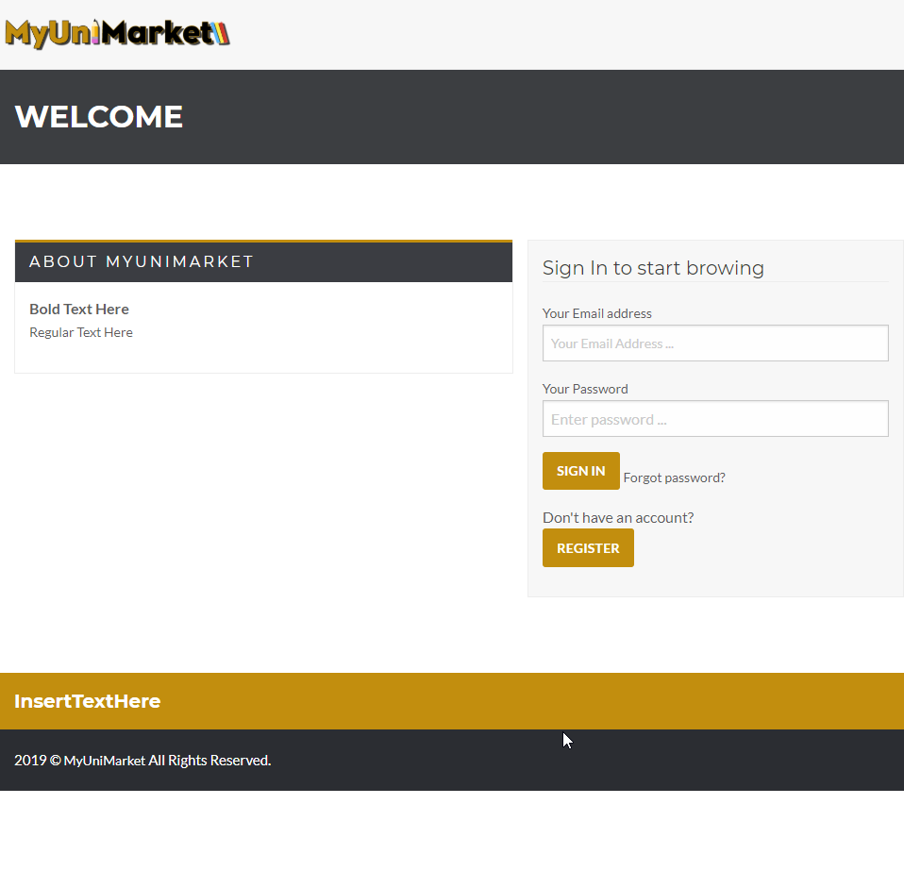
5. The user is deleted from the database. 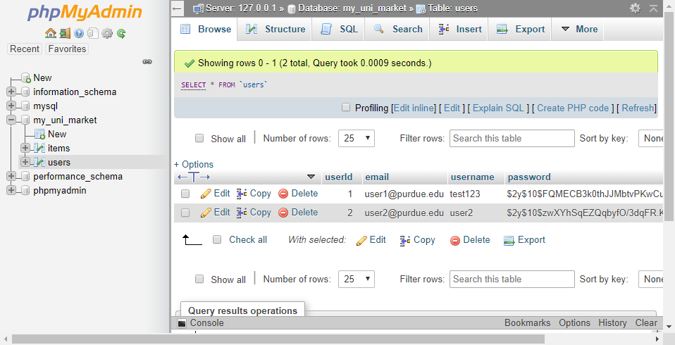

Expected Result: After deleting the account the user must be signed out automatically and their account details must be removed from the database.

Test Result: **PASSED**